Team Name

Team Members: Anthony Mosley, Michael Burns, Joey Haywood, Hayden Kanek, Aroum Zombra

**Chapter 1**

Vision #1: Cloud-based Bus Pass System – reliable, fast, and safe way of buying bus tickets for all levels i.e. individuals, schools, government. Replace the need for manual buying at bus counters and with login page, will put your previous bus tickets information into database.

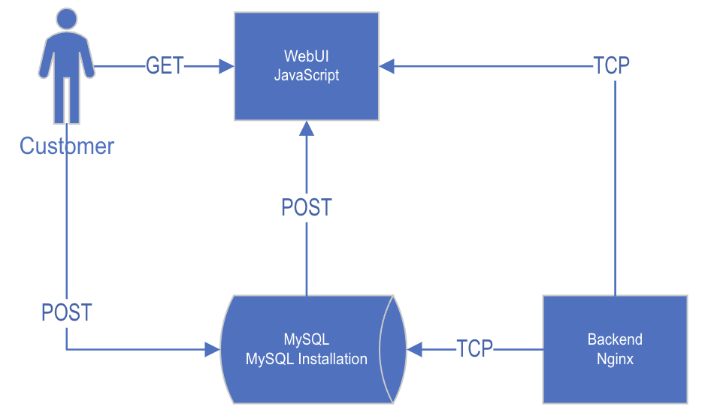

**Chapter 2**

Implementation vision #1: Using HTML, CSS, PHP, JavaScript, SQL

Application webpage – HTML, CSS for main webpage for bus pass site, ExpressJS or Nginx backend allows communication with database.

User interface – PHP, JavaScript allows for signing in and 2FA

Buy/Checkout page – JavaScript allows for user input for ticket options

Booking information/ticket display– SQL puts booking information into database and displays ticket

**Resumes**

Anthony Mosley

Oxford, Pennsylvania

**Contact Information**

**Email:** [ajmosley345@gmail.com](mailto:ajmosley345@gmail.com)

**Phone:** (717)-371-0907

**Linkedin:** linkedin.com/in/anthony-mosley-8b7a21168

**Experience**

**Stoner Inc.**

Junior Network Administrator/IT Support

May 2022 - Aug 2022/Dec 2022-Jan 2023

* Executed smaller tasks to aid the team with their projects
* Helped set up their new phone system (RingCentral)
* Assisted multiple departments with technology setup and issues
* Setup 30+ machines to be deployed across the company
* Worked with their servers to convert an old camera server into a virtual machine

**Education**

**West Chester University of Pennsylvania**

Bachelor of Science - BS, Computer Science

Aug 2020 - May 2024

**Skills**

* Systems Administration
  + Server Administration/Maintenance
  + Computer Networking
* Backend Development
  + MySQL
  + Nginx
* Software Engineering
  + Python
  + JavaScript

**Michael Burns**

Bath, PA 18014

**Email:** [mburns0163@gmail.com](mailto:mburns0163@gmail.com)

**Phone:** 484 892 0163

**Work Experience**

**IT Technician**

IT Edge - West Chester, PA

September 2022 to Present

• Configure all incoming client orders to IT Edge technology standards.

• Install devices with all required software and troubleshoot for any issues before getting ready for delivery.

• Troubleshoot and repair hardware and software for client equipment.

• Assist with on-site setup and configuration, as well as troubleshooting client issues.

• Contact clients with updates on repairs, and work towards the most effective solution.

• Document and enter all work done each shift.

**Multiple Positions**

Beck's Land and Sea House - Nazareth, PA

May 2017 to July 2022

**Dishwasher:**

• Washed kitchen equipment, plates, silverware, and glasses.

• Completed food preparation by kitchen needs.

**Server Assistant:**

• Took food out to guests.

• Would buss and clean tables for next guests.

• Put unfinished meals in boxes for guests.

• Help servers with any additional needs for guests.

• Communicate with the kitchen and servers.

**Server:**

• Take guests' orders with a positive and friendly attitude.

• Answer questions guests have about our menu and make recommendations.

• Have extensive knowledge of the menu and ingredients in the dishes.

• Prepare the dining room by polishing tables, silverware, vacuuming, and maintaining the general cleanliness of the restaurant.

**Bartender**

• Cut and juice fruit only needed for that shift to ensure the freshness and quality of the product.

• Prepare the bar for service by thoroughly cleaning, as well as ensuring there are enough liquor, beer, wine, and soft drinks stocked.

• Extensive knowledge of all drinks on and off our drink menu.

• Knowledge to be able to pair food and wine together.

• Create weekly drink specials with other bartenders and management.

**Education**

**West Chester University of Pennsylvania - West Chester, PA**

Bachelor of Science – BS, Computer Science

January 2022 to Present

**Northampton Area Community College - Bethlehem, PA**

Applied Associate of Science – AAS, Information Technology

September 2019 to December 2021

**Northampton Area High School - Northampton, PA**

High School Diploma

September 2015 to June 2019

**Skills**

• Serving Experience

• Busser

• Kitchen Experience

• Restaurant Experience

• POS

• Food Service

• Bartending

• Food Preparation

• Customer service

• Upselling

• Organizational Skills

• Food Safety

• Cleaning

• Computer Operation

• Microsoft Office

• C++ (1 year)

• Computer networking (2 years)

• Java

• Computer Science

• HTML5

• C/C++

• Technical support

• Software troubleshooting

**Joseph Haywood**

Quakertown, PA 18951

**Email:** [joey.haywood49@outlook.com](mailto:joey.haywood49@outlook.com)

**Phone:** 267-347-0880

**Experience:**

August 2020-Present

Intelligence Sergeant (35F10), Pennsylvania Army National Guard

S2 Staff Section, 56th Stryker Brigade Combat Team

1. Accountable of all section equipment and vehicles

* Assists with physical security protocols and handling of classified materials
* Supports junior enlisted soldiers in military and civilian careers

October 2016-August 2020

Intelligence Analyst (35F), Pennsylvania Army National Guard

Deployed to Poland in S2 Staff Section, 278th Armored Cavalry Regiment March 2019-March 2020

1. Handled classified material on daily basis
2. Performed maintenance checks on vehicles and equipment
3. Created and briefed mission sensitive reports to Squadron Commander and NATO Allies
4. Reviewed and updated SCAR (security clearance access roster)

March 2018-March 2019

Checkout Coach, Giant Food Stores

Customer service representative and front-end team leader

* Handled thousands of dollars in cash office deposits and withdrawals
* Utilized POS (point of sale) system to support associate and customer needs

**Education:**

August 2020 – May 2024

B.S. Computer Science & Minor in Applied Statistics

**West Chester University** **GPA: 3.54**

October 2017 – February 2018

Intelligence Operation Studies

**Cochise College**  **GPA: 3.48**

**Skills:**

* Programming: Java, R, C, and Haskell
* Database management systems: mySQL
* Information security, physical security, and communication security
* Handling of classified materials
* Proficient in Microsoft Office
* Computer Security and networking

**Aroum Zombra**

**Contact Information:**

Phone: 267 530 8083

Email: [zombraahmed12@gmail.com](mailto:zombraahmed12@gmail.com)

LinkedIn: <https://www.linkedin.com/in/zombraahmed>

**Education:**

**West Chester University =>**  **West Chester, PA**

Bachelor of Sciences in Computer Sciences September 2021

**Expected Graduation:**  May 2023

**Blackwood Community college:** New Jersey, NJ

Associate in Computer Science May 2021

**Relevant Courses Worked:**

Foundation in C++, Java Programming, Data Structures & Algorithms, Programming Language Concepts and Paradigms, Computer Security & Ethics, Calculus I&II, Physics I&II, User Interface, Software Testing

**Skills:**

**Programming Languages:** Java, Python, C++

**User Interface:** JavaScript, HTML5, CSS, Node.js, React

**Software Engineering:** Object Oriented Programming, Software Design, UML diagram

**Work Experience:**

**Uber Technology/ Delivery & Passengers Driver**

* Driving passengers safely to their destination
* Delivering food at Uber/Eat
* Managing frequently issues related to the trips
* Good leadership and communication skills

**Technical Project:**

* Achieved some projects Front-End web application
* Achieved some projects Back-End web application
* Tackled Data Structure with Binary Seach Tree

